**DESIGN OF ACTIVE FILTERS – LOWPASS FILTER, HIGHPASS AND BANDPASS FILTER**

**Exp No: 7 Date: 10/03/2022**

**Objective:**

**To design, simulate and verify low pass, high pass and band pass filter.**

**Software Required:**

LT SPICE - XVII

**Theory:**

Low Pass Filter: -

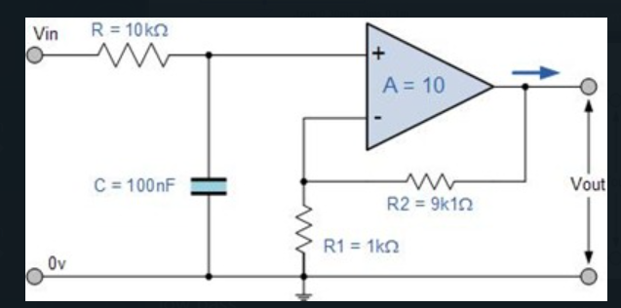

The most common and easily understood active filter is the Active Low Pass Filter. Its principle of operation and frequency response is exactly the same as those for the previously seen passive filter, the only difference this time is that it uses an op-amp for amplification and gain control.

The frequency response of the circuit will be the same as that for the passive RC filter, except that the amplitude of the output is increased by the pass band gain, AF of the amplifier. For a non-inverting amplifier circuit, the magnitude of the voltage gain for the filter is given as a function of the feedback resistor ( R2 ) divided by its corresponding input resistor ( R1 ) value and is given as:

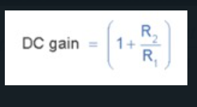

Therefore, the gain of an active low pass filter as a function of frequency will be:

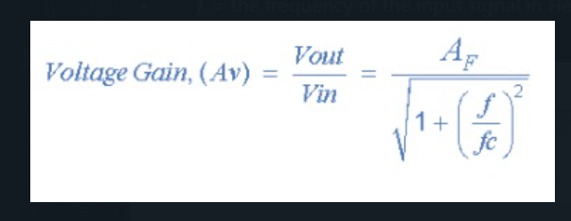

Where:

• AF = the pass band gain of the filter, (1 + R2/R1)

• ƒ = the frequency of the input signal in Hertz, (Hz)

• ƒc = the cut-off frequency in Hertz, (Hz)

**High Pass Filter:**

A first-order (single-pole) Active High Pass Filter as its name implies, attenuates low frequencies and passes high frequency signals. It consists simply of a passive filter section followed by a non-inverting operational amplifier. The frequency response of the circuit is the same as that of the passive filter, except that the amplitude of the signal is increased by the gain of the amplifier and for a non-inverting amplifier the value of the pass band voltage gain is given as 1 + R2/R1, the same as for the low pass filter circuit.

**Band Pass Filter:**

For a low pass filter this pass band starts from 0Hz or DC and continues up to the specified cut-off frequency point at -3dB down from the maximum pass band gain. Equally, for a high pass filter the pass band starts from this -3dB cut-off frequency and continues up to infinity or the maximum open loop gain for an active filter.

However, the Active Band Pass Filter is slightly different in that it is a frequency selective filter circuit used in electronic systems to separate a signal at one particular frequency, or a range of signals that lie within a certain “band” of frequencies from signals at all other frequencies. This band or range of frequencies is set between two cut-off or corner frequency points labelled the “lower frequency” ( ƒL ) and the “higher frequency” ( ƒH ) while attenuating any signals outside of these two points.

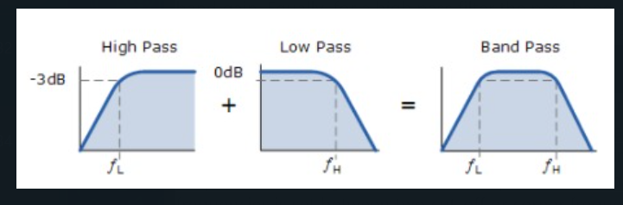

**Procedure: -**

1. **Open LT Spice and click on new schematic to start the circuit making.**
2. **Components needed are: wires, ground, resistor, op-amp and voltage sources.**
3. **Place them all in the required way as per the requirement of circuit analysis.**
4. **Perform required analysis like transient or ac etc. (simulation commands)**
5. **Run the schematic once the circuit is complete**
6. **Click above the ac input voltage source for the input signal**
7. **Click above the load resistor to obtain the output signal.**
8. **Analyse the input and output obtained from the circuit analysis on LT Spice.**
9. **Save the schematic and continue further analysis if required.**

LOW PASS FILTER: -

CIRCUIT: -

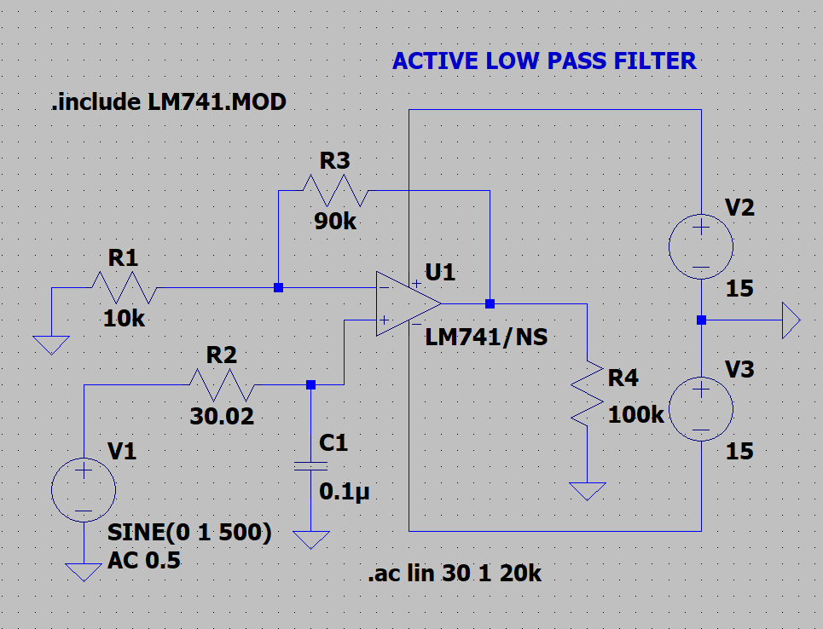

OUTPUT:

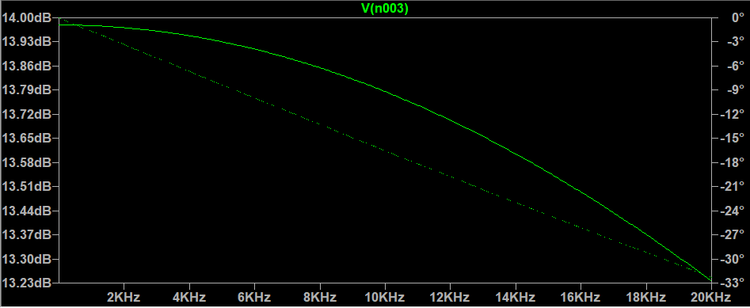

HIGH PASS: -

CIRCUIT:

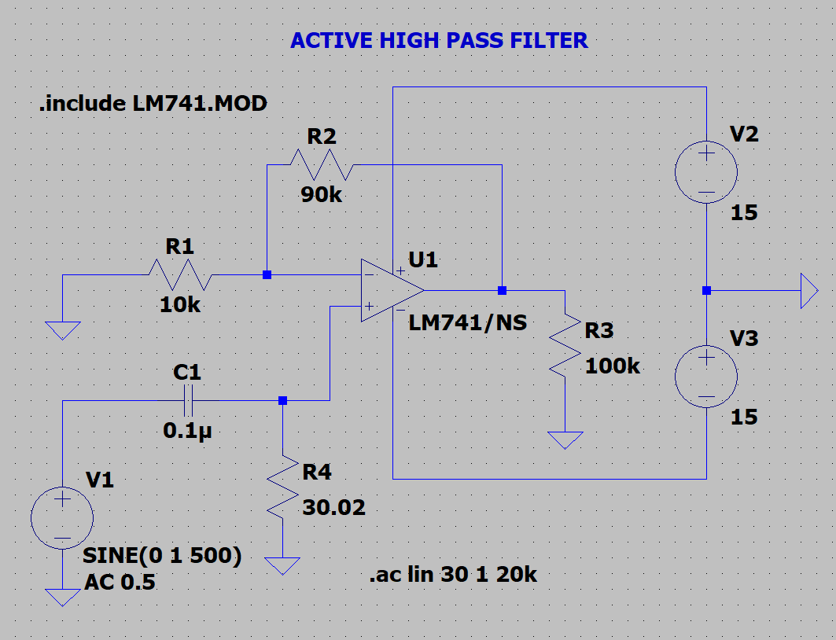

OUTPUT: -

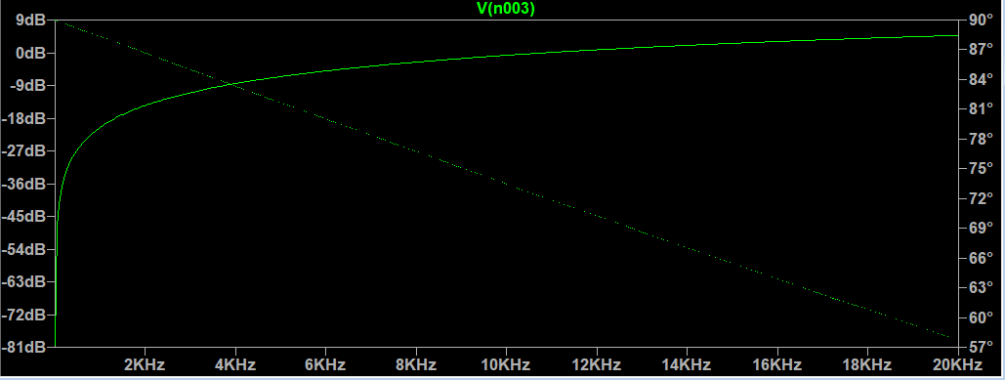

BAND PASS: -

CIRCUIT:

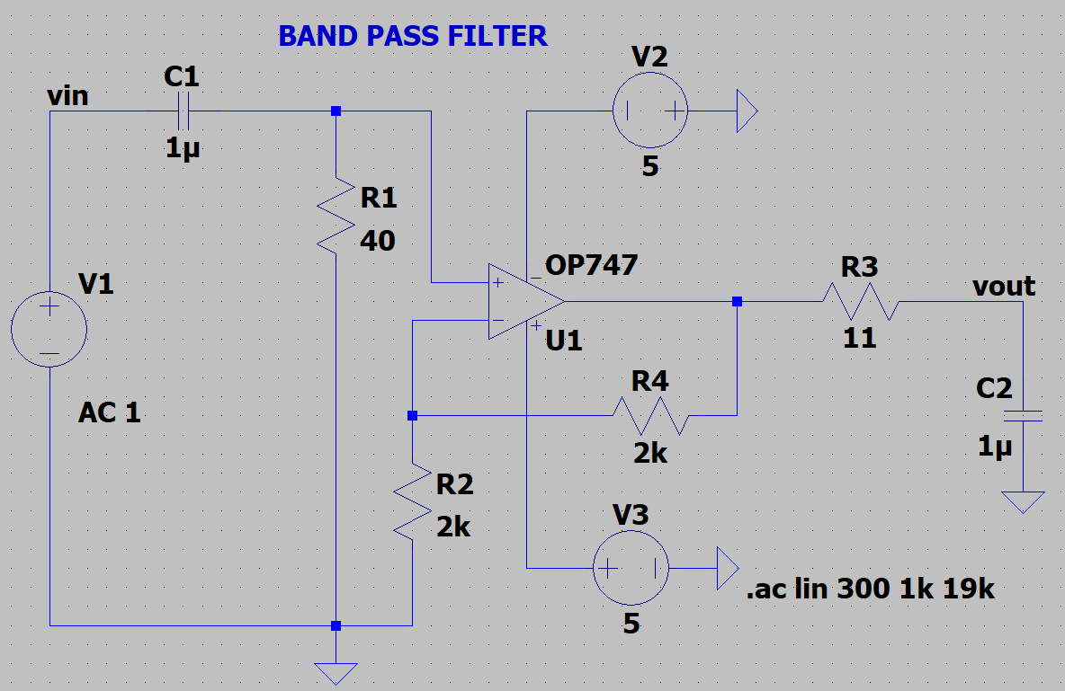

OUTPUT: -

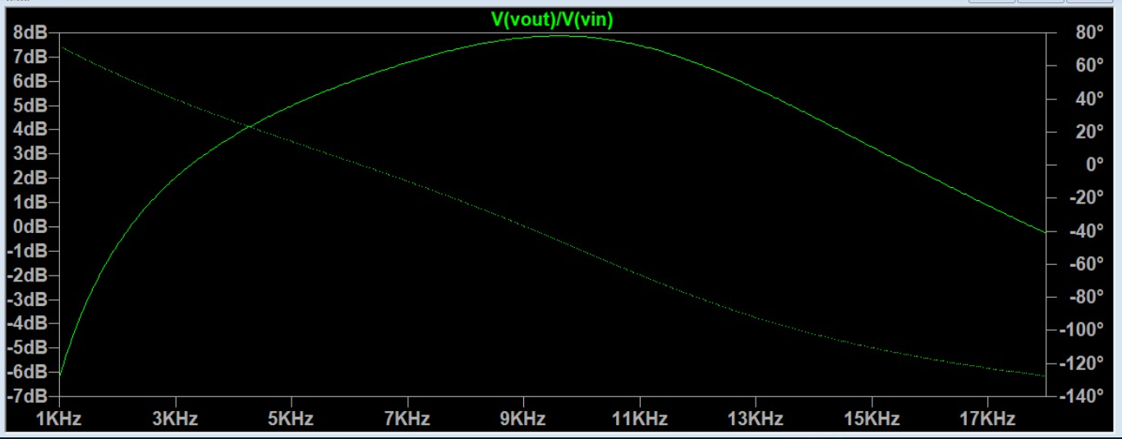

**RESULT: -**

**Thus, HIGH PASS, LOW PASS AND BAND PASS FILTERS designed, tested and verified using LTSPICE.**